UNIVERSITY OF DELHI



An Android Application to play songs

TOPICS TO BE COVERED :

* INTRODUCTION
* TECHNOLOGY USED
* FLOW DIAGRAM
* FEATURES OF THE APP
* DRAWBACKS
* AREAS OF IMPROVEMENT
* CONCLUSION
* REFERENCES

|  |  |  |  |  |
| --- | --- | --- | --- | --- |
|  | | | |  | | --- | | INTRODUCTION | |
| 1. | RHYTHM, an app to match your rhythm. Rhythm mobile application is an android based application to listen to the music of your choice. | | |
| 2. | We focused more on the easily accessible content of their choice for our users and that's why we made fewer and straightforward options to make it easy while using. | | |
| 3. | This app facilitates a user in different ways in listening to music. We have 3 categories in which the first one we have 5 sub-categories user can choose according to their choice. | | |
| 4. | On clicking the application, we kept an animation to make our application look more attractive. It will appear just after we click the app icon. After this, a screen with three options will open up from where we provided different ways to play songs. | | |
| 5. | We have made this app on the basis of whatever we learnt about the language, Java and additionally we have used XML to make the app look better. This is a basic app, but we learnt whatever we could while making this as a group project. | | |

TECHNOLOGY USED

Languages used :

●

JAV

A

●

XML

Software Used

●

Android Studio

●

Android Emula

tor: API level 29 or higher.

|  |  |
| --- | --- |
|  | FLOW DIAGRAM |
| |  | | --- | | FLOW CHART | |

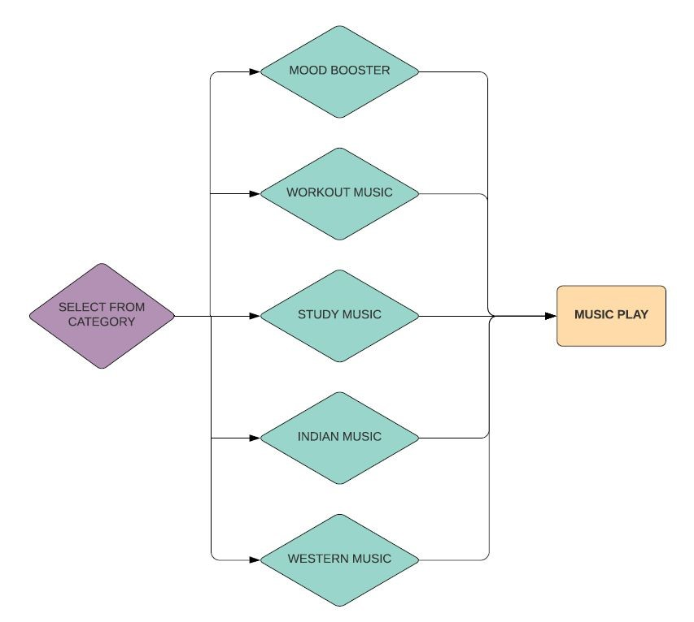

FEATURES OF THE APP

|  |  |
| --- | --- |
| 1. | This application is an offline application , the user doesn't need to have an internet connection and can listen to his/her favourite music without any interruption. |
| 2. | Users can listen to music depending on the current mood as this application provides a category of music. |
| 3. | If User is confused in music taste , can choose the random feature of the application and listen to variety of songs randomly |
| 4. | Users can play the songs and audio files which are already downloaded in the user's device(phone) in case the user can’t find the exact place of the downloaded songs in the device. |

# DRAWBACKS

|  |  |
| --- | --- |
| 1. | This application does not store any data of the user including their personal info like phone no and mail id. |
| 2. | This application can’t show the previous status of the user, hence the features like recommendation of songs based on users interest cannot be implemented. |
| 3. | Since this is an offline application, it has limited songs only. But we can surely upgrade it to provide more variety of songs to the user. |

# IMPLEMENTATION



(with screenshots of application)

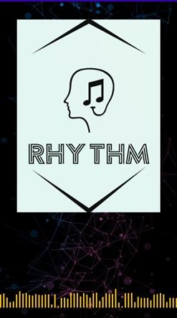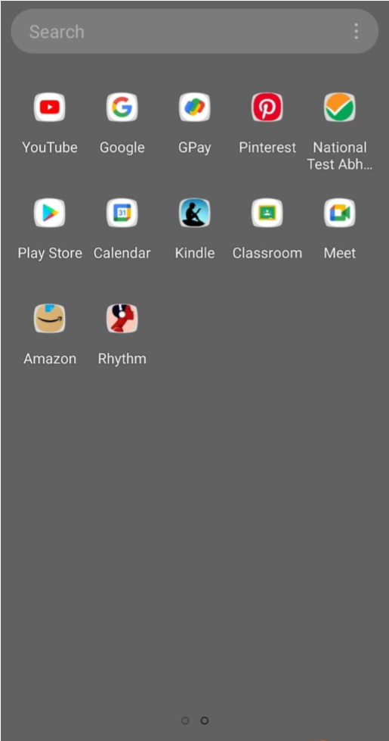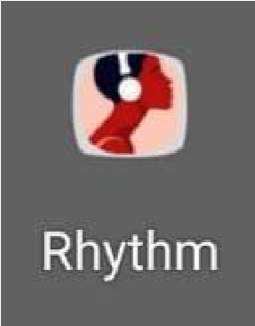

(THE APP ICON) (SPLASH SCREEN - animate() gets

called for 2 second with translation along y axis)

(If user selects option 1) 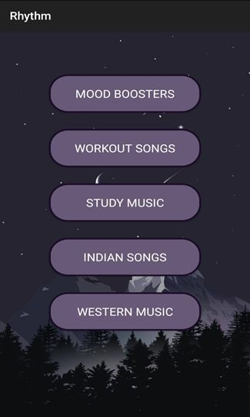

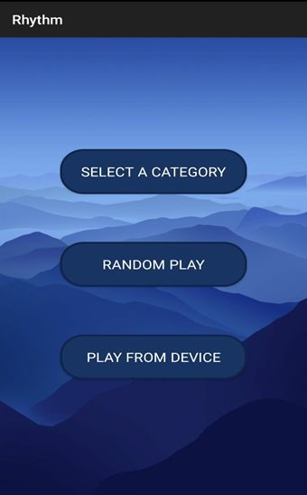

(First screen after splash screen, (Screen after “SELECT A CATEGORY”, displaying 3 choices -> using displaying 5 different tastes of music AnimatorListener, at animation’s ->using OnClickListener , matches the end Choice.java gets implemented) id for the very first button ,

Choice2.java gets implemented)

(If user selects option 2) 



(Screen to play random songs from all the (First screen after splash screen, available songs -> using OnClickListener , displaying 3 choices -> using for the 2nd button,MainActivity with 3 AnimatorListener, at animation’s end functions namely : musicpause, musiplay,

Choice.java gets implemented) musicstop for 3 respective buttons,called) (If user selects option 3) 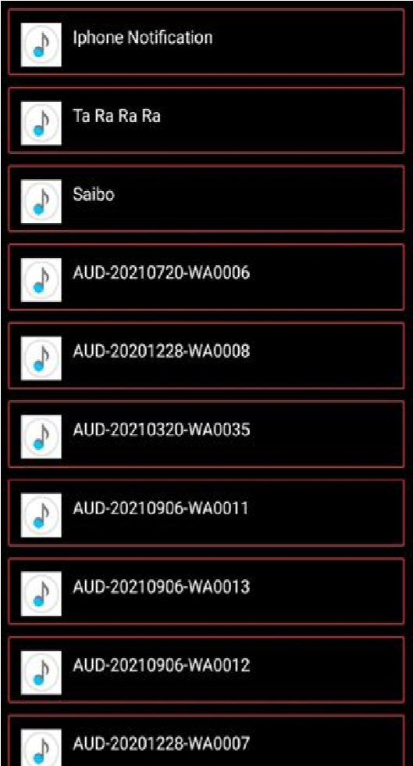



(First screen after splash screen, (List view of audio files available in user’s displaying 3 choices -> using device -> using OnClickListener , for the AnimatorListener, at animation’s end 3rd button, MusicList.java starts with

Choice.java gets implemented) runtimepermission(), displaysongs() and BaseAdapter)

(Screen after “SELECT A CATEGORY”, displaying 5 different tastes of music ->using OnClickListener , matches the id

for the very first button , Choice2.java gets

implemented)

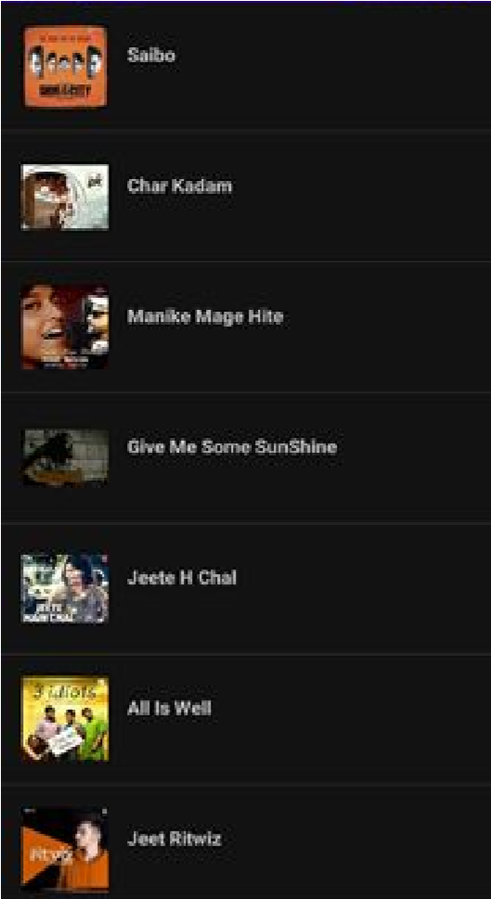(List view of songs under category “MOOD



(

If user selects option

1)

BOOSTERS” -> using onClickListener for 1st button, MoodBoosters.java starts withonItemClick(), onCompletionListener and audio focus)

(Screen after “SELECT A CATEGORY”, displaying 5 different tastes of music -> using OnClickListener , matches the id

for the very first button , Choice2.java gets implemented)

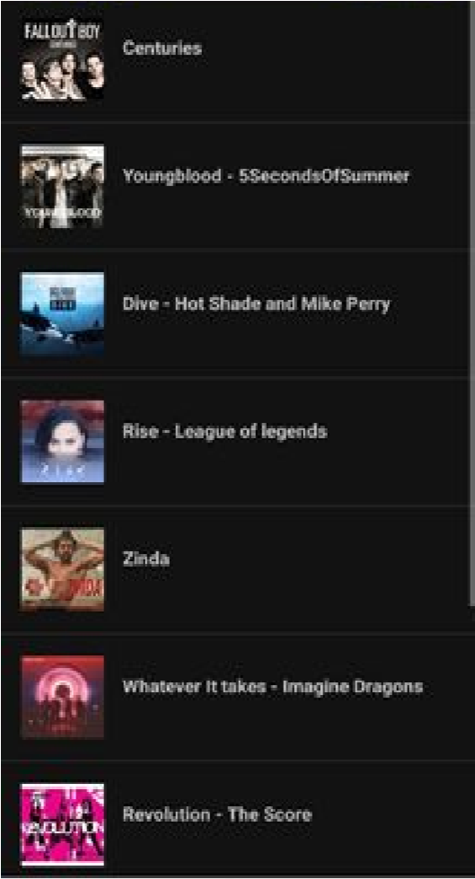(List view of songs under category “WORKOUT MUSIC” -> using onClickListener for 2nd button,Workout.java starts with onItemClick(),onCompletionListener and audio focus )



)

(

If user selects option

2)

(Screen after “SELECT A CATEGORY”, displaying 5 different tastes of music->using OnClickListener , matches the id for the very first button , Choice2.java gets implemented)

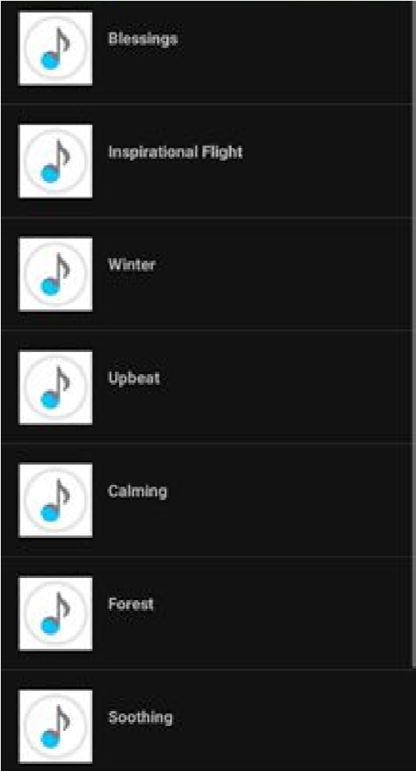(List view of songs under category “STUDY MUSIC”->using onClickListener for 3rd button Study.java starts with on ItemClick(),onCompletionListener and audio focus )



(

If user selects option

3)

(Screen after “SELECT A CATEGORY”, displaying 5 different tastes of music -> using OnClickListener , matches the id

for the very first button , Choice2.java gets implemented)

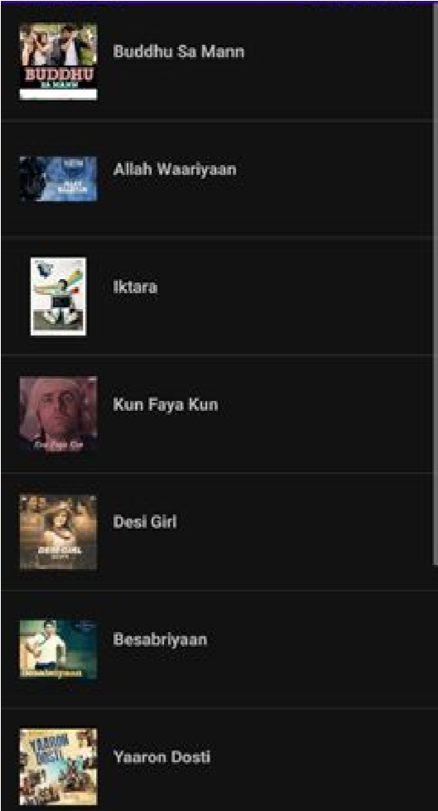(List view of songs under category “INDIAN SONGS” -> using onClickListener for 4th button,Indian.java starts with onItemClick(),onCompletionListener and audio focus )



(

If user selects option

4)

(Screen after “SELECT A CATEGORY”, displaying 5 different tastes of music ->using OnClickListener , matches the id for the very first button , Choice2.java gets implemented)

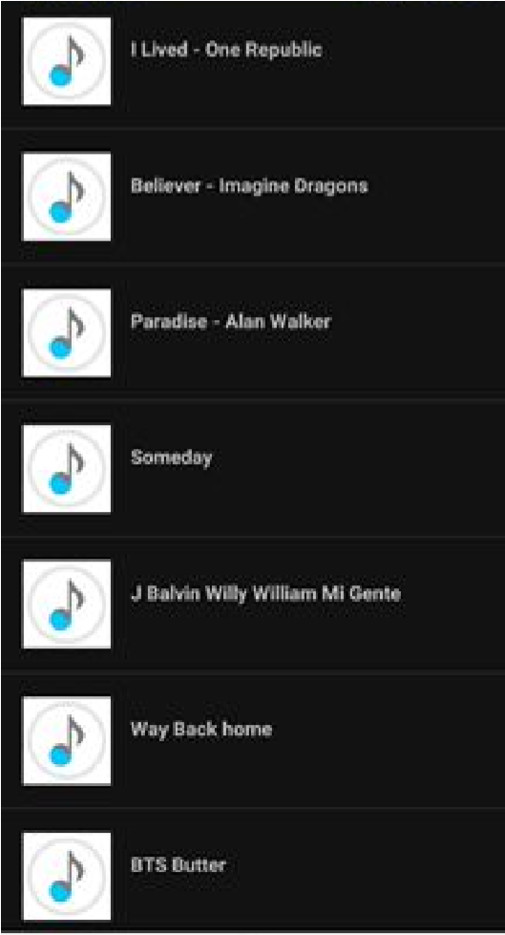(List view of songs under category “WESTERN MUSIC” -> using onClickListener for 5th button,Western.java starts with onItemClick(),onCompletionListener and audio focus )



(

If user selects option

5)

|  |  |  |  |
| --- | --- | --- | --- |
|  | |  | | --- | | (If user clicks on any audio file to play ) | |  |
|  |

(List view of audio files available in (Screen after user selects any file to play from user’s device -> using the device->using the song’s id,

OnClickListener , for the 3rd button, PlayerActivity.java starts with startAnimation, MusicList.java starts with onOptionItemSelected(), onDestroy() functions



runtimepermission(),displaysongs() and SeekBarChangeListener to play and

and BaseAdapter) manage seek bar)

|  |  |  |  |  |  |
| --- | --- | --- | --- | --- | --- |
| |  | | --- | | CONCLUSION | |  | | | |
| ● | | User friendly application , easy to use and understand. | | |
| ● | | Compact Application - Does not require much space in the device | | |
| ● | Can play any mp3 and audio files from the device. | | | | |
| ● | | Provides 5 category of songs to choose from - Mood boosters, Workout music, study music, Indian music, Western music | | |
| ● | | Can play songs randomly. | | | |
| ● | | Can be used offline, does not require internet. | | | |

AREAS OF IMPROVEMENT

|  |  |  |
| --- | --- | --- |
| ● | | Firebase can be attached in order to store user’s data and previous status , it makes this application more flexible to use. |
| ● | | Songs can be displayed as per user’s age . |
| ● | | Recommendations can be given to the user , depending on the user’s history and their taste |
| ● | Internet permission can be added in order to explore through a sea of songs. | |
| ● | | Application look / design can be improved. |

## REFERENCES

* https://developer.android.com/studio

(To read about everything related to all the functions used in the app)

* https://stackoverflow.com

(To clear the doubts and errors and for better implementation of code)

* https://www.udacity.com/

(To get the idea of how apps are made, we referred few tutorials)

* https://github.com/

(To get the idea of music apps already made, for reference)

* https://oyebesmartest.com/s/mobile-amoled-wallpapers

(For the wallpapers used while making the background of the screens)

* https://www.tailorbrands.com/logo-maker

(To make the logo of the app)